Use a command to show the current working directory





List the directory contents in the short and long format

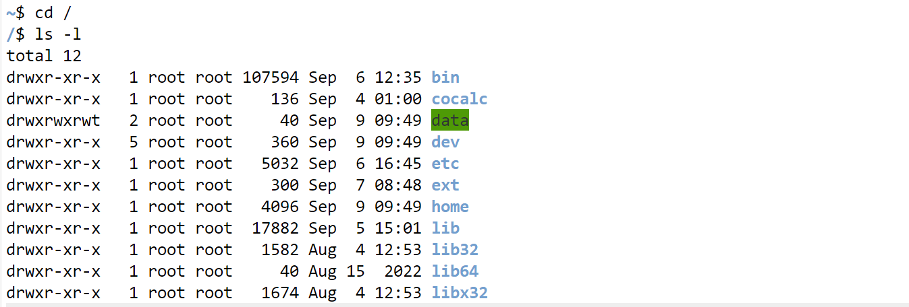

Explore attributes given in long format

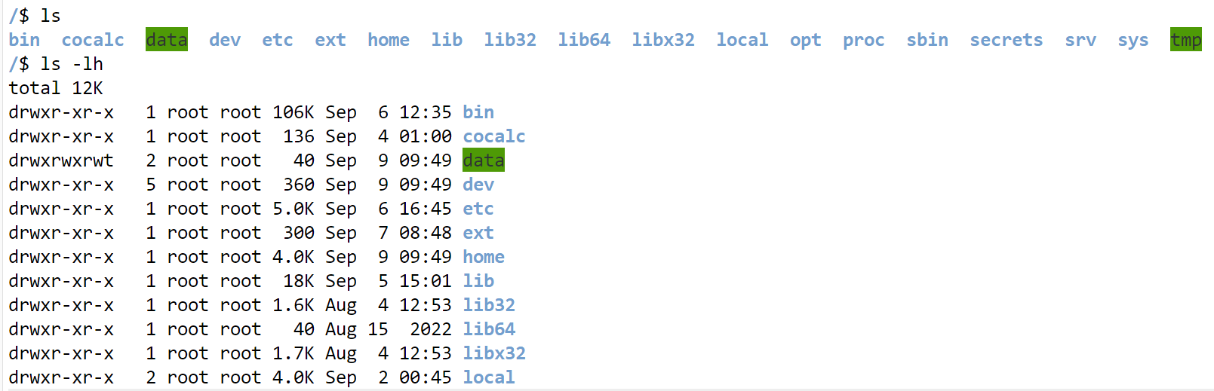

List all files along with hidden files in the current working directory

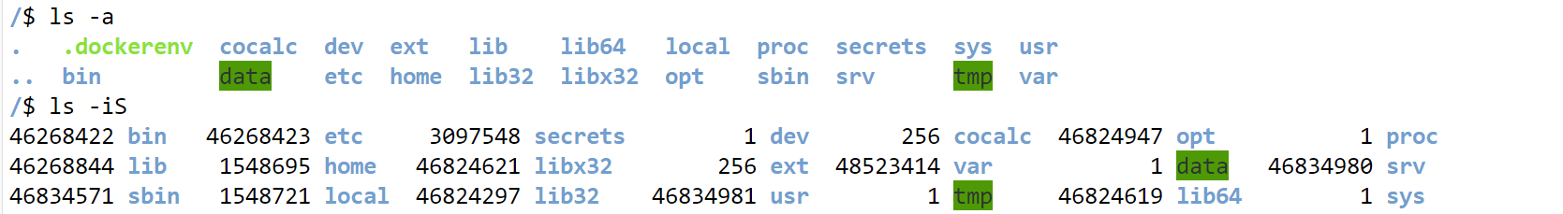

Make a directory and name it as cdac-dir and change the current working directory to the new directory.

Create following nested directories inside the current directory by evoking a single command for only one time

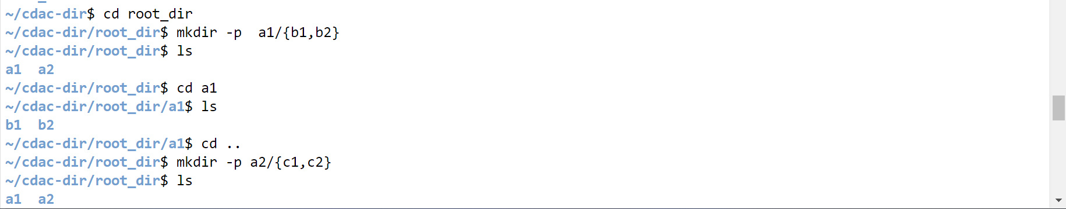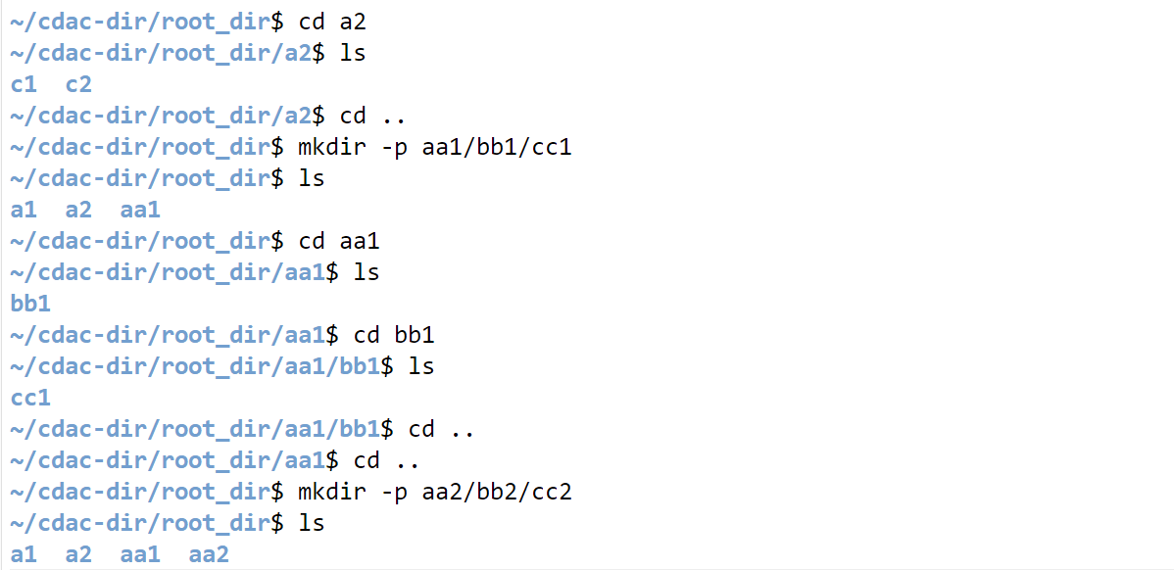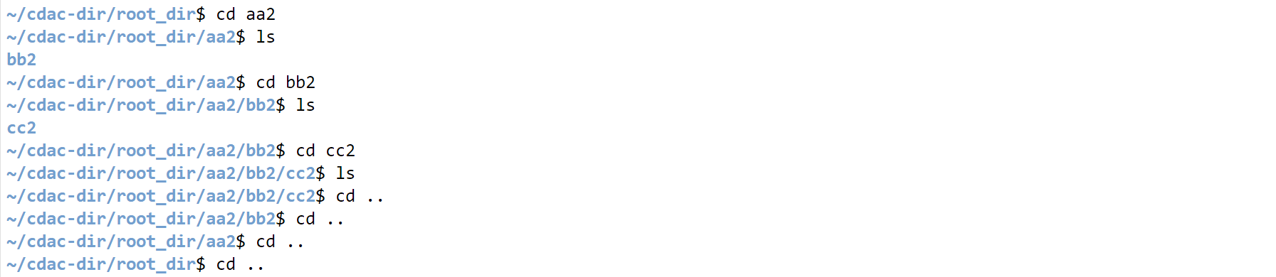

Explore the man page of make directory.

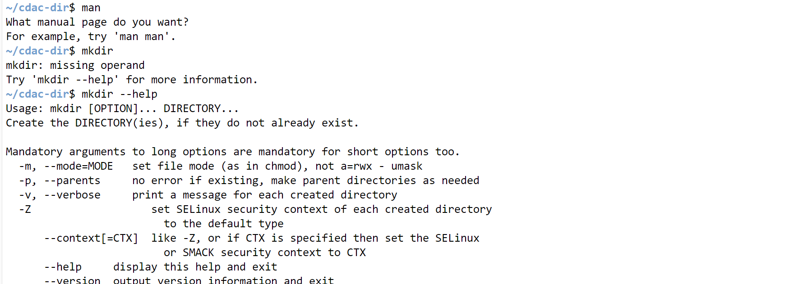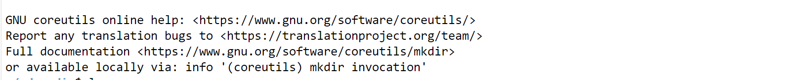

List the directories, then remove the cdac directory and list the folders again to show that it is no longer present

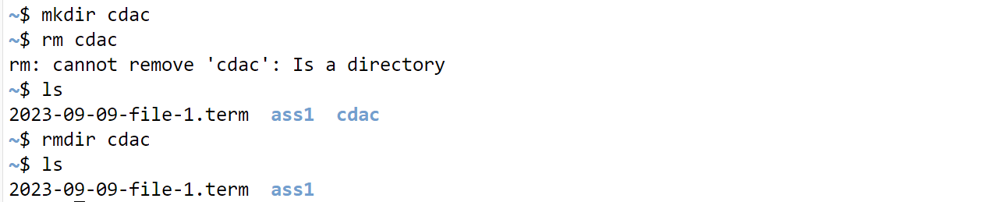

List processes running in shell, all running processes and show top processes in decreasing order of their resources utilization

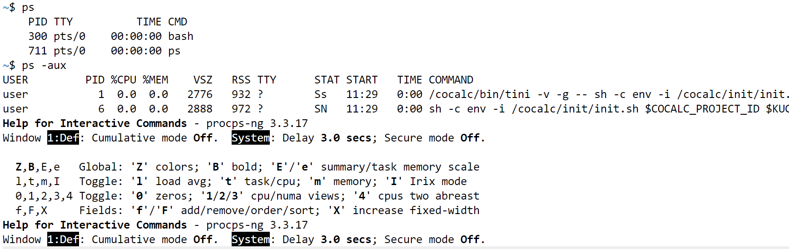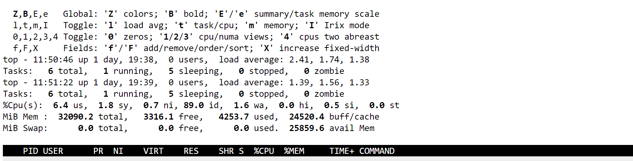

Display current time and calculator

Change the current date and time of the system to the following 14th March 2024 10:10:00 AM

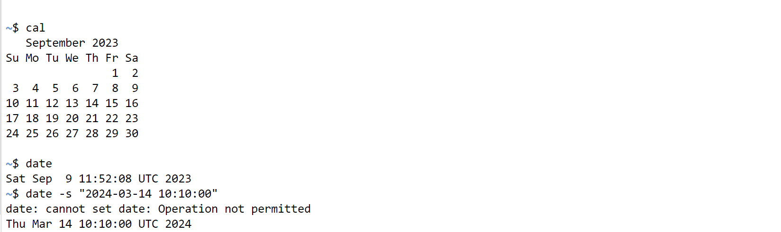

Who, whoami, whatis, whereis

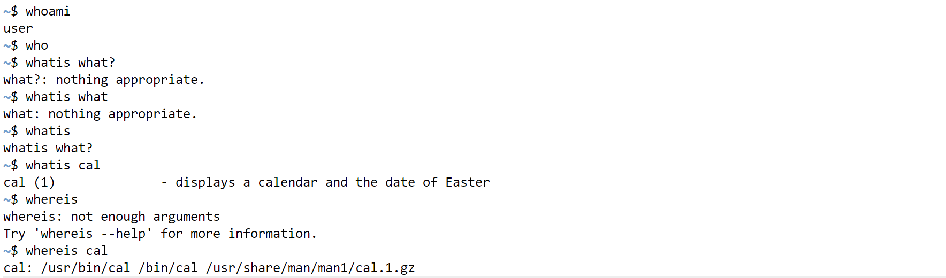

How do you use the ls command to list all files and directories in the current directory?

